Nick Scott
CS-320
Professor Norman
8/23/2026
Project Two
The software requirements were heavily relied on when considering the testing approach. The requirements of each Class object were written in a way such that each requirement can clearly be linked to a testing case. For example, “The task object shall have a required name String field that cannot be longer than 20 characters. The name field shall not be null” has three requirements which creates three different test cases: name can’t be longer than 20 characters, name cannot be null, and name is required. This then guides the different functions created for the unit tests, like so:
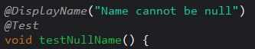
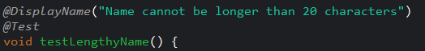
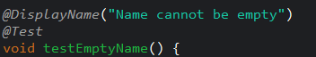
I feel confident about the overall quality of my JUnit tests on a basis of coverage percentage. For both the Contact and Task coverage, my tests had a coverage of about 86- 90%, which means the majority of my lines of code have been tested and executed to validate its effectiveness. The primary classes had 100% of its code executed during testing.
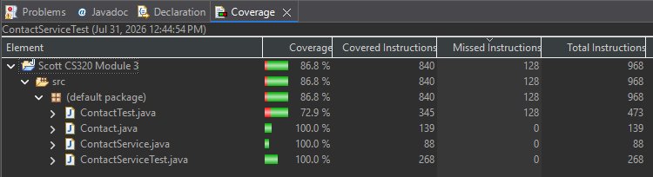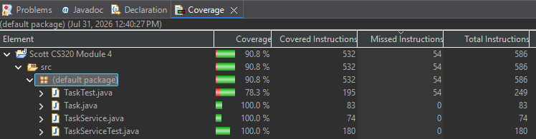
I ensured my code was technically sound by making sure the tests leave no room for interpretation as to whether the success passed or failed. A strong example is the delete task function. In this function, steps are taken to not only check the number of tasks to make sure the correct amount is contained within each step, but the contents of non-deleted tasks are checked to make sure the correct task was deleted. Lastly, a check to find the deleted task is made, to ensure the deleted task cannot be returned. This thoroughness ensures that the task is deleted.
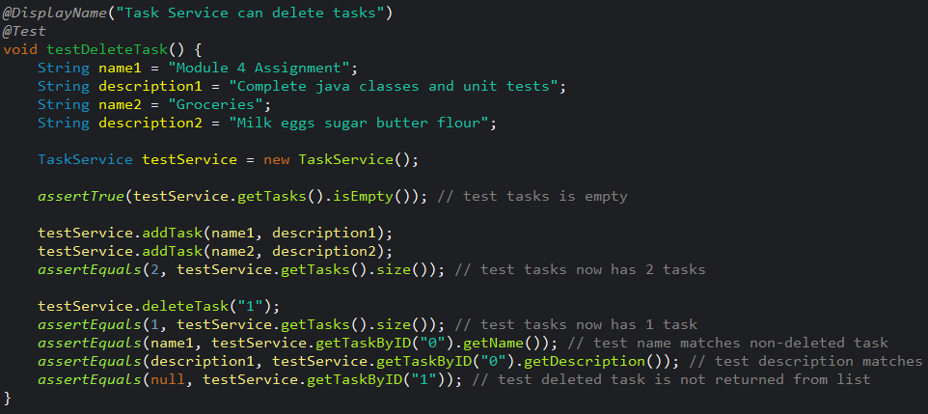
Lastly, I ensured my code was efficient by thinking about the tests in a “cascading” way. For example, if one test validates a certain piece of functionality, I do not need to re-test that functionality in a different test. This means the tests are not executing unnecessary assertions. For example, in ContactTest, when testing the constructor, the assert functions check to make sure the object’s data is valid by using the appropriate getter functions. Since the tests work here, there is no need to make separate tests for each accessor function.
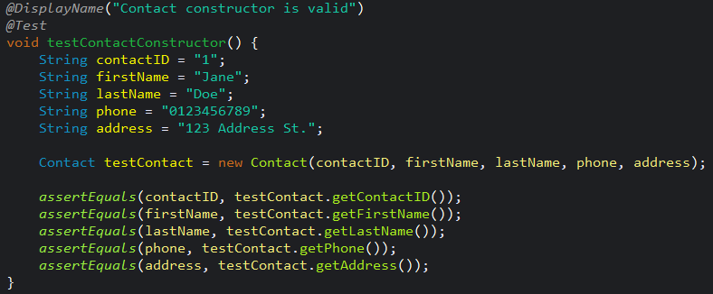
Over the past three modules, I have implemented examples of both unit testing and static testing. Unit tests have been the primary vehicle of testing, through JUnit. During this process, I would interpret each individual requirement for a given class and translate them into functions that test functionality bit by bit. By definition of unit testing, classes and methods are tested in isolation from each other to check that base functionality is working as intended. Since the scale of the assignment was small, I manually ran these unit tests each time, as opposed to automating them. There, failing tests would signify which areas of code are not working as expected, and led me to the corresponding method to find a fix. For example, in Module 5, the JUnit test to make sure an appointment could not be made in the past was not throwing an error as expected. This led me to the exact lines of code I needed to change in order to make the test succeed. Unit testing is important in large projects as failing to verify individual functionality can lead to larger problems down the line that could make it difficult to identify where the problem is coming from.
JUnit was also used to consider code coverage. In Module 5, 91.3% of the code was covered by my JUnit tests, which means the majority of lines of code have been run when verifying individual functionality. In a small-scale assignment like mine, it is easier to achieve high code coverage, but when working with large-scale projects across multiple teams, it is more difficult to test each individual line. This testing technique gives developers an important metric to check the effectiveness of their tests when running their code.
Additionally, I would do instances of static testing, such as code reviews of functions I wrote to verify that each part of the functionality requirements were met. Without running the code, I would ensure that I would address what was needed through adding a comment next to the linked lines of code. When reviewing, I would identify functionality was missing simply by reviewing the code I had written. For example, in Module 3, I had forgotten to verify that Contact attributes are “required”, meaning they should not be an empty String. Through static testing, I was able to identify missing functionality from the code without having to directly run it. Static testing proves even more beneficial in workplaces where you can have peers review each other’s code in order to get fresh perspectives. It is also one of the most time and cost efficient testing techniques as it doesn’t require the development and execution of tests such as through JUnit.
These testing techniques above are all examples of white-box testing, which meant I had full access to the source code and back-end while testing. Black-box testing was not used during these modules, as it would require interfaces that one could use without having to interact with the actual code, which doesn’t exist for this assignment. However, in professional projects, this type of testing is important as it closely mimics what end users will expect to deal with, which is how the majority of users interact with an app. It doesn’t care about how the program was developed; just its efficiency and how it operates.
Another testing technique that was unused over the past couple weeks was integration testing. While I conducted unit testing to test each class individually (Contact, Task, and Appointment), integration testing would go farther and test how each of these work together as a system. This would make sense as a next step for this project, if these had special interactions with each other and extra functionality between each class. This is especially important in large-scale projects where multiple working pieces need to come together. Unit testing may have verified that each class works independently, but many issues will arise when combining them together.
Additional types of testing, such as performance, stress, and load tests, were not applied to this project, as it doesn’t make much sense to test for such a small application. However, these types of tests are incredibly important for applications that use a lot of memory or power. It is important for software teams to pinpoint and identify the correct types of tests to use in different moments for their projects, as each test verifies something different and identifies different problems.
As a software tester, there were many moments in which I employed caution. It was important to be deliberate with the tests created to make sure there was nothing missed. For example, with the similarity of certain test cases, it would be easy to copy-and-paste already created tests. However, being cautious while doing this is very important. Forgetting to change one part could mean the test is no longer behaving the way it should. It could fly by the radar, too, for example, the test could show as passing but the actual code is testing a different feature since it was copy-and-pasted. Verifying my own tests through code coverage was important to make sure nothing slipped in between the cracks.
Additionally, the tests, although similar, have various complexities that make each one slightly different in its implementation. While some fields had a maximum of 10 characters, for example, a phone number field would have to be exactly 10 characters. While it would be easy to group these two as having similar requirements, the implementation through code ended up being different and required me, as a tester, to appreciate the complexities of the codebase and features that were being implemented.
It was important for me during this project to keep my developer brain separate from my testing one, due to the biases that could arise during. For example, I could create tests in such a way that I know will pass because I already understand how the code and functions are supposed to work in what order. This could happen unconsciously, as you already understand the logic within the codebase. As a tester, it is your job to identify deficiencies in logic, and it will be extra difficult to do this when you may be blind to these due to your already intimate work crafting a solution. Because of this, having a different person as a software tester will get a fresh set of eyes on your work and will have fresh perspectives and a more objective view of the code. However, there are times where it isn’t possible to do this. In my project, I would try to develop the tests and the codebase during different coding sessions, to have as fresh of a perspective as possible when reviewing.
Technical debt is easy to build up in projects, especially when working in large-scale projects across multiple teams. In large-scale projects, you will have multiple teams relying on your work and trusting that you have put the diligent effort forth to make sure your program is well-tested and structured. Deficiencies or inefficient logic will not only cause bigger problems down the road, but it will be more difficult to identify where the problem is coming from. Therefore, it is imperative to be diligent during each step. If a team were to ensure their unit tests are valid, when larger-scale testing such as system testing or acceptance testing happens later down the line, the team is not stuck on smaller issues that were skipped upon earlier in the project.
If I weren’t diligent with the tests in this class project, issues would arise when systems would be implemented together, such as when Contact, Task, and Appointment are all working together within one app. As a coder, I feel I pay close attention to details and read through the expected functionality over and over to ensure nothing is missed. It will be important for me to continue to apply these principles as I enter the professional field.

